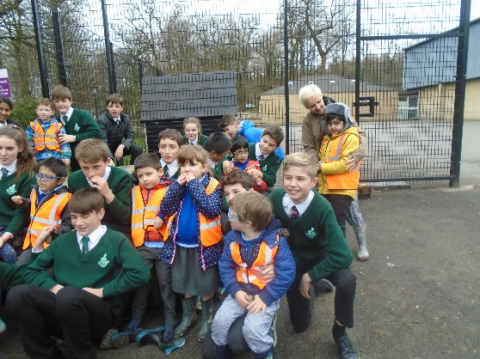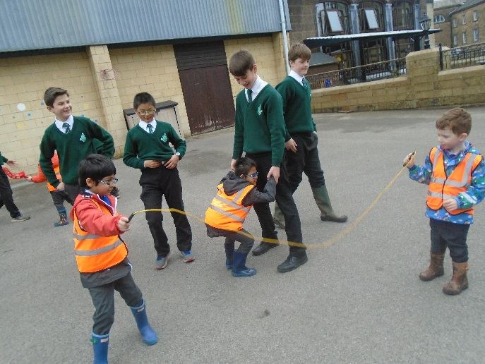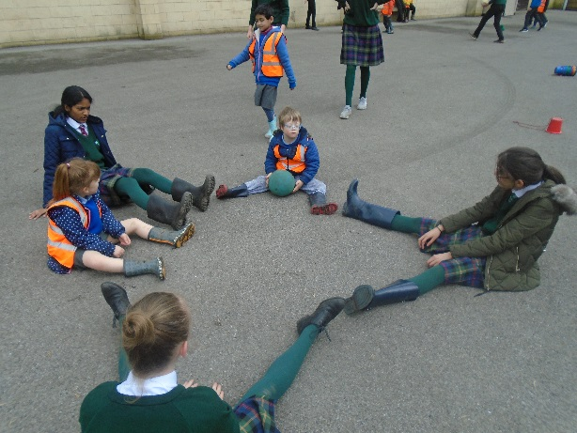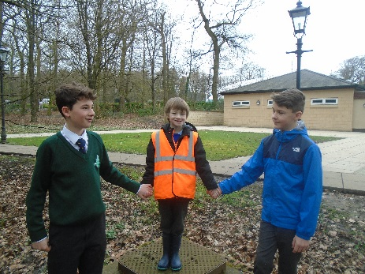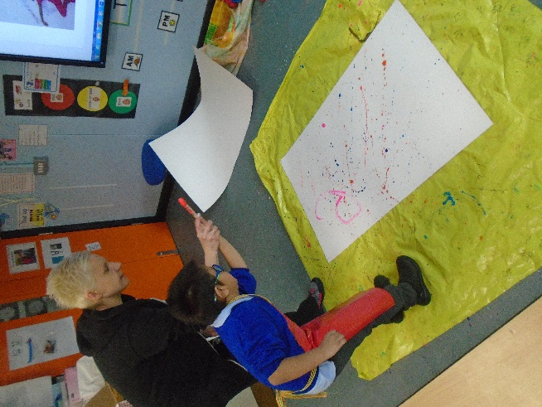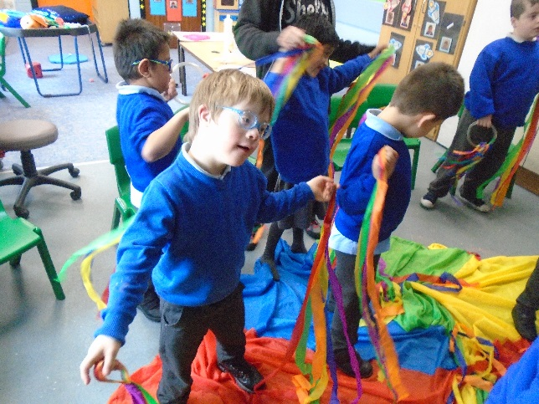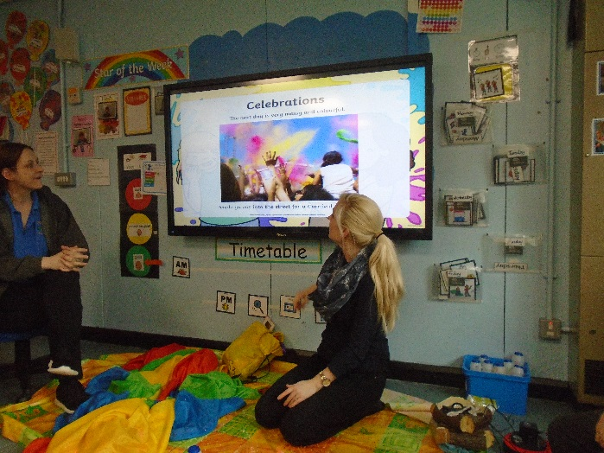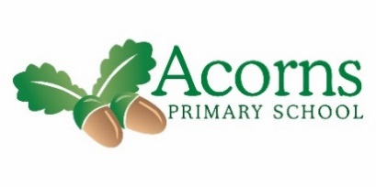

The children have done some fantastic work this week on our class story – The Rainbow Fish! We listened carefully and remembered words to describe how he looks from last week and also how he was feeling!! We did some wonderful mark making and independent writing too. In maths we have been busy learning and exploring sharing/fractions. We made two equal groups using our coloured fish, some of us worked hard in this session and showed a good understanding of sharing. We also shared some Rainbow sweets – we enjoyed eating them afterwards the most though!!

For our celebration of Holi we shared a powerpoint to learn about what happens at Holi and who and why it is celebrated. We used our bright colourful ribbons to dance for the “Festival of Light” and made bright and colourful pictures flicking/splattering paints.

On Thursday we enjoyed a marvellous visit to Stonyhurst College. Here we met some lovely year 8 pupils who escorted us around the grounds on a welly walk. We all had a great time playing with the older boys and girls and on our return to school we looked back through the pictures to discuss our day. The children remembered their names and talked about what they had enjoyed about the day. Such a lovely rewarding experience for all involved!

**Next Week...** is extended writing week at school, so the children will be enjoying marking activities and opportunities to develop their writing skills based on their knowledge of our class story.

Reminders- Please continue to read with your child and practice their flashcards ☺

Cedar Class Weekly News – 15/03/19