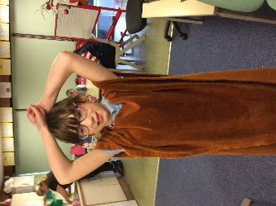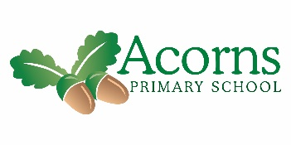

Merry Christmas!

**This Week**

Thank you to all families and friends who came to watch the Christmas Show. We’re sure you’ll agree that it was amazing! The children worked so hard and we’re really proud of them all. Thank you for all the costumes, too.

We had a great Christmas party with games, dancing, food and a visit from Father Christmas. The children were brilliantly behaved, and got an extra present from Rock FM’s ‘Cash for Kids’.

**Next Week**

The week we come back will be a normal week.

Some pupils will be attending an activity morning at Heyhouses C of E School in Lytham St Annes – pupils attending will receive a letter.

Please send PE kits and outdoor learning clothes back into school (wellies and waterproofs). Thank you.

**Reminders**

**We start back at school for the Spring Term on Monday 7th January at the normal time.**

**And finally…**

Have a lovely Christmas break.

Best seasonal wishes

from

Oak Class Team

**W/B 17th December 2018**

Oak Class’s Weekly News