

This Week….

It’s been really lovely celebrating Christmas. Everyone has been excited, especially Jess!

We were superstars in the Christmas Production, we all managed to get on stage and show off our lovely costumes and dances. Party day was fasntastic, Father Christmas brought us all presents, then on Thursday we got more from Rock FM Cash For Kids.

We had end of term assembly on Friday and enjoyed spending time together, playing games and music.

Thank you to everyone for your kind gifts, we really appreciate it. It’s been a lovely first term in Woodlands class and we are all very proud of all the children’s achievements so far this year.

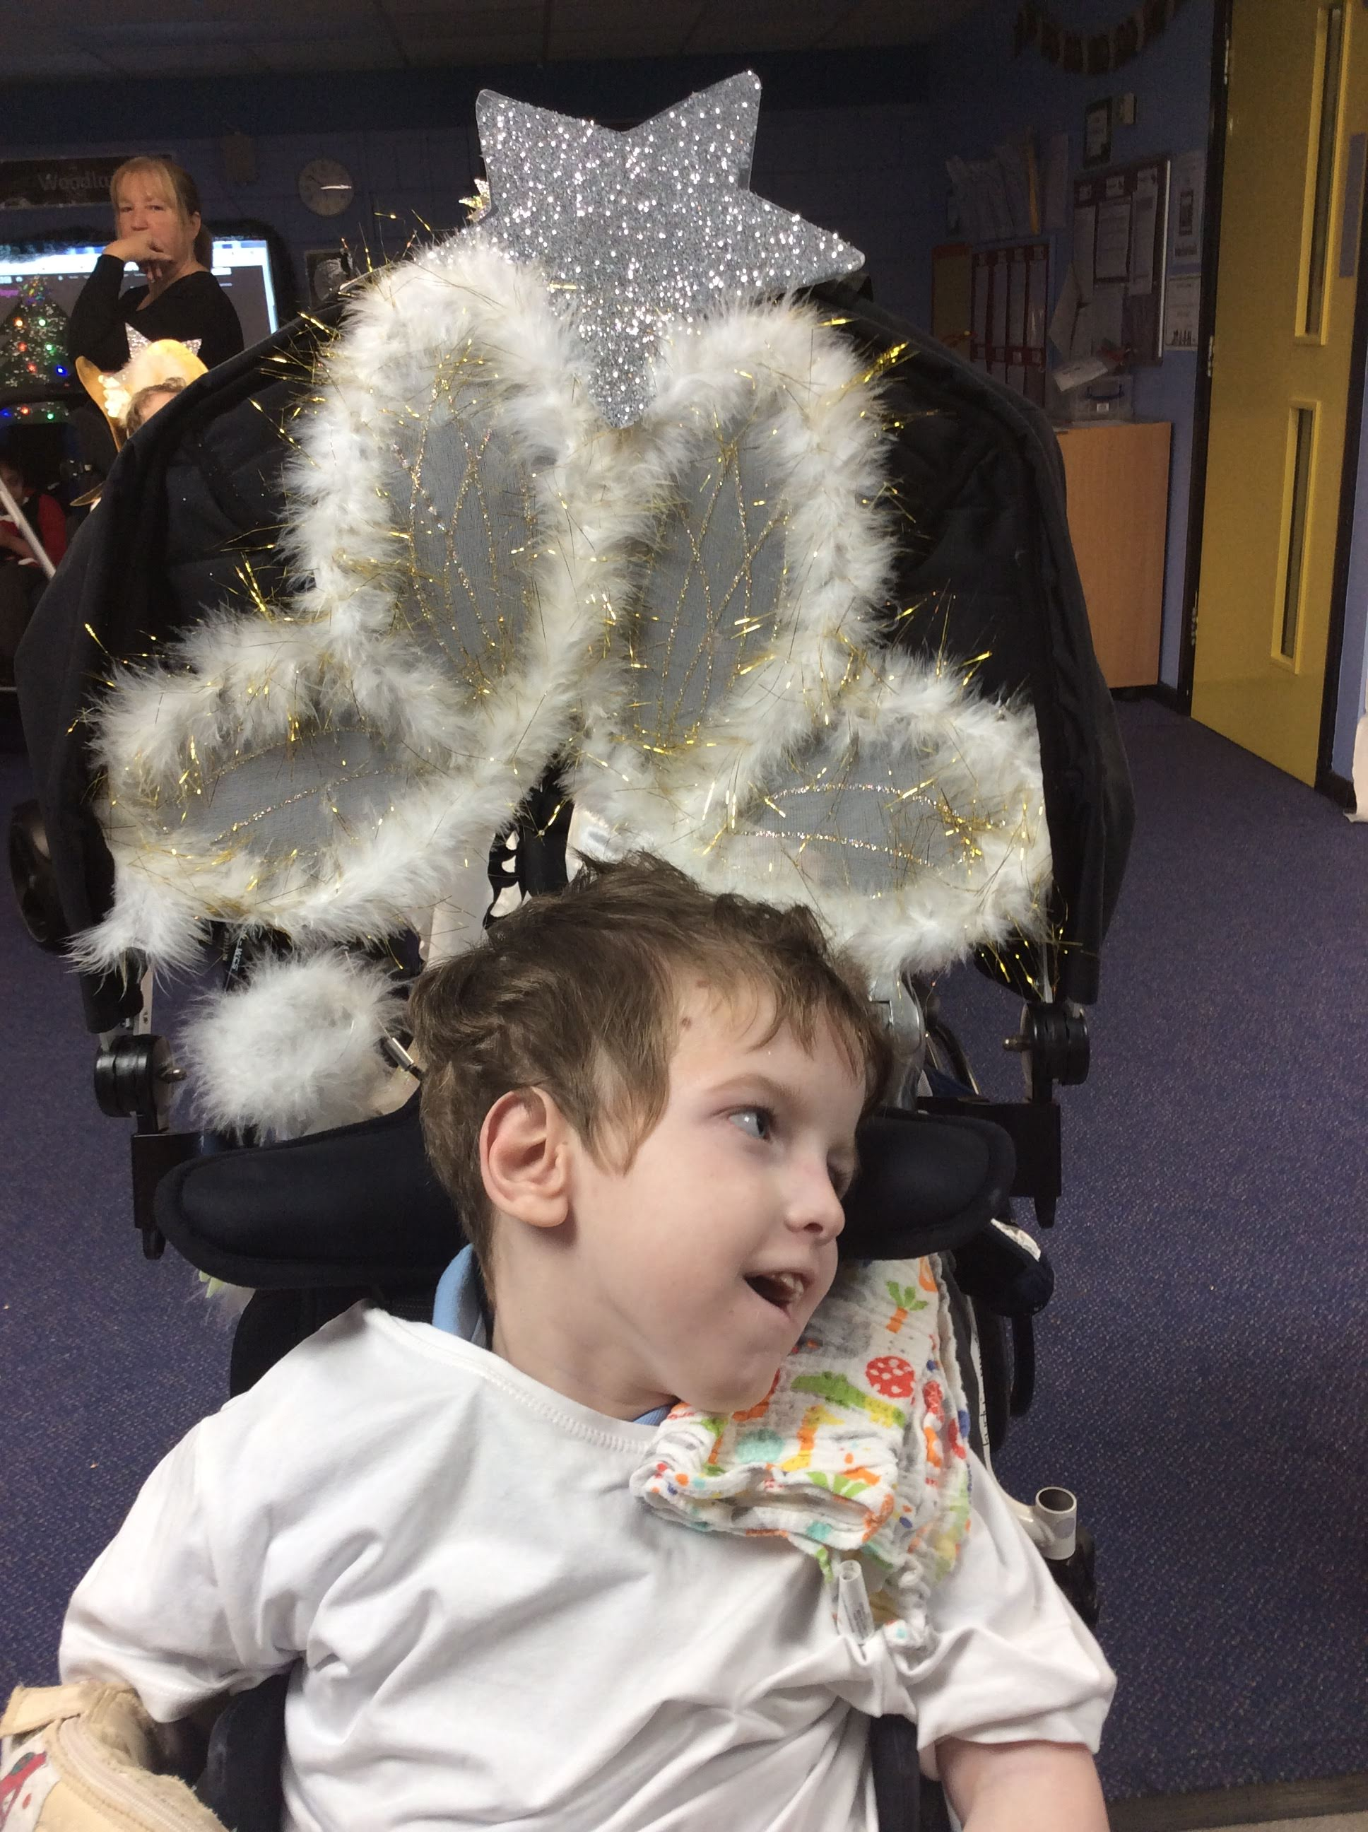 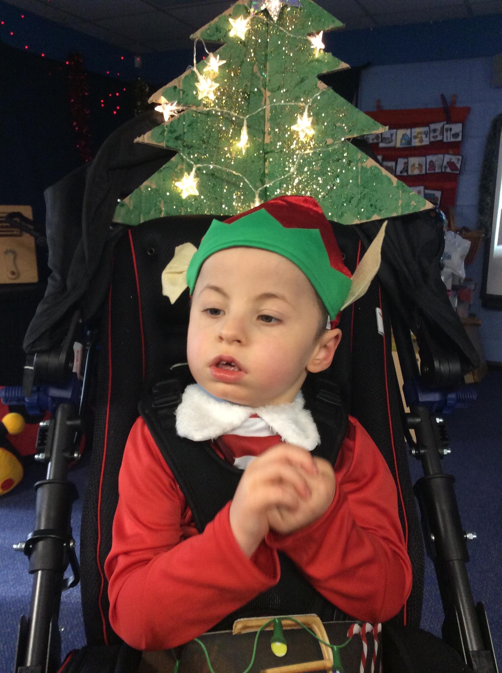 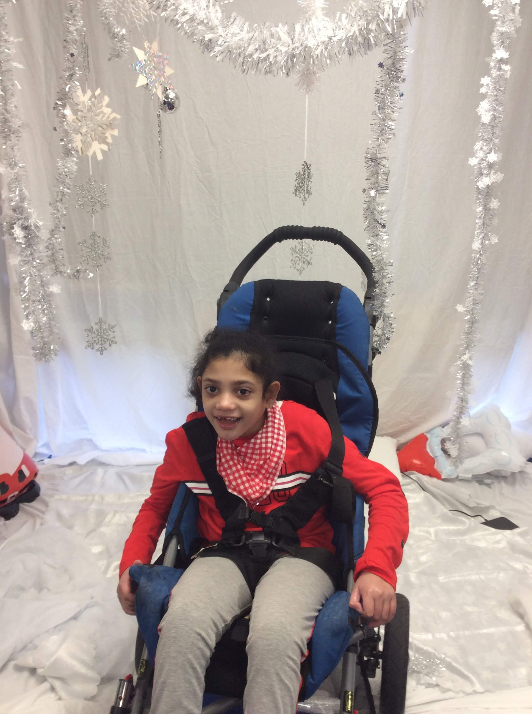 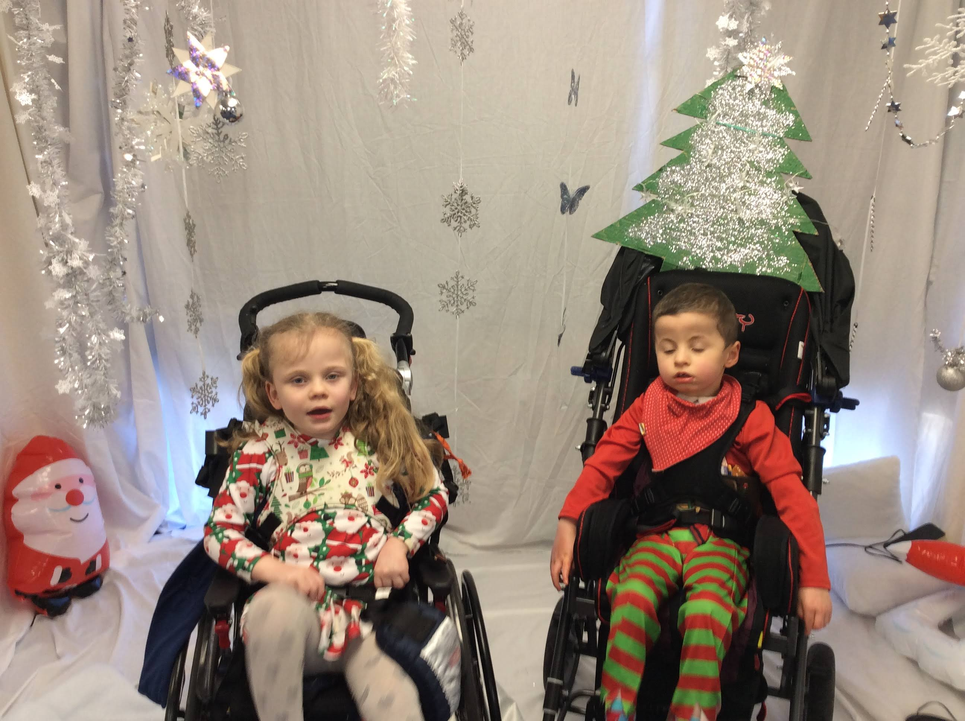

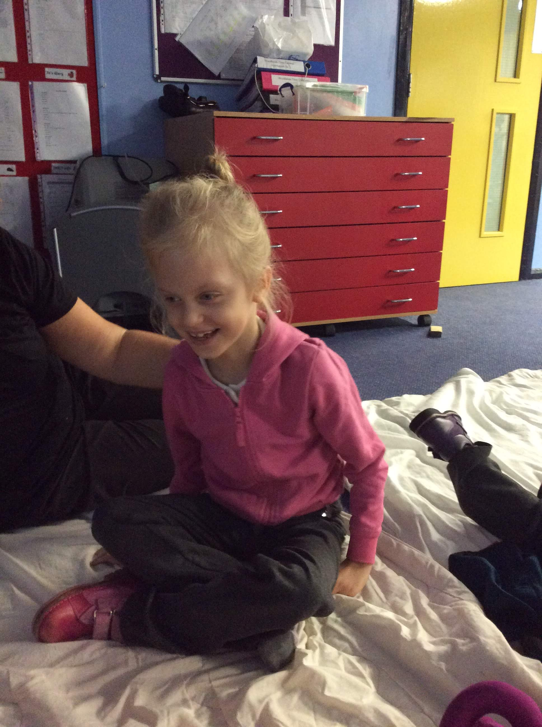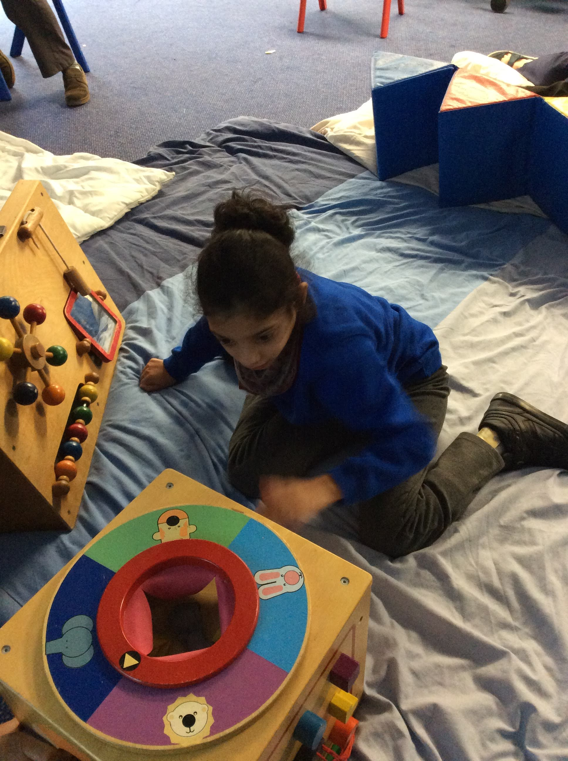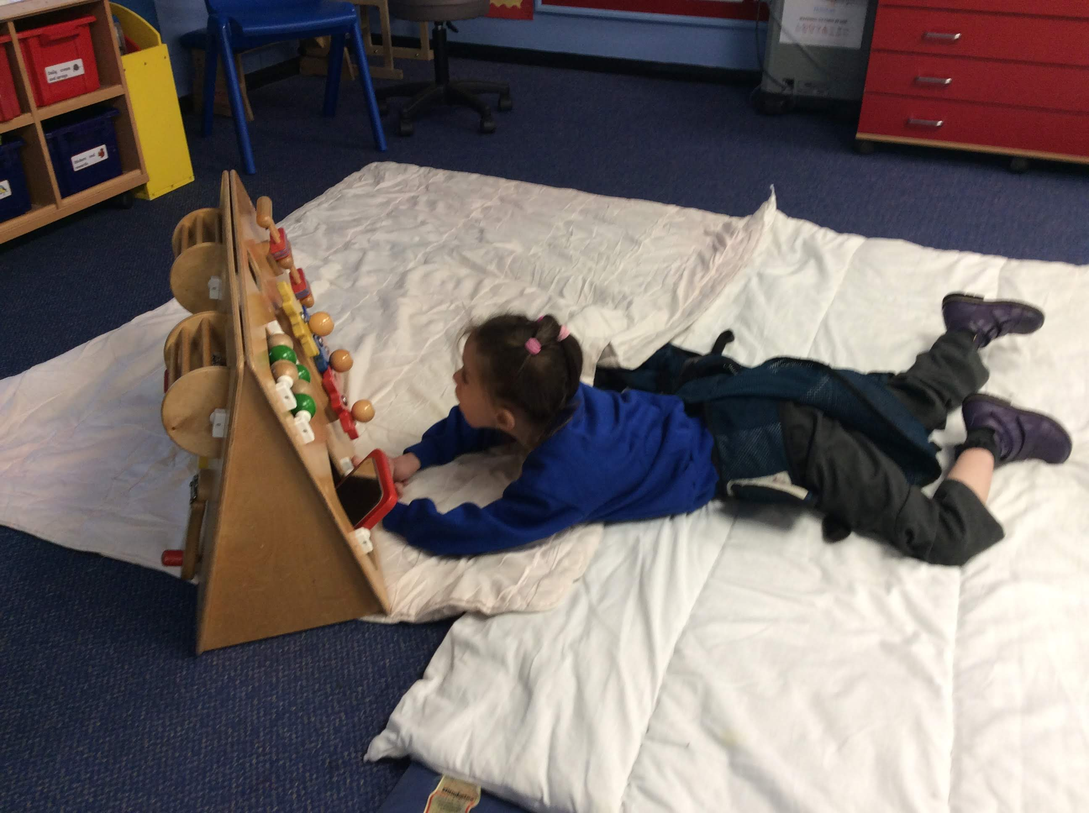

**Next Week...**

It is Christmas!!! We hope that you have a fantastic Christmas, a lovely break and a Happy New Year. Have a lovely rest and we will see you in 2019.

**Reminders**

School re-opens on Monday 7th January.

**And Finally…**

Well done to Myles for winning the Sport’s award this term. Myles has been working really hard on his independent sitting skills.

Woodland Class’s Weekly News

**W/B 17th December 2018**