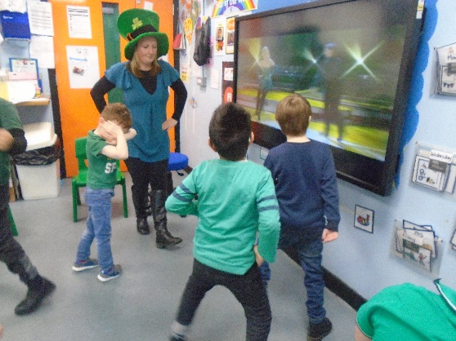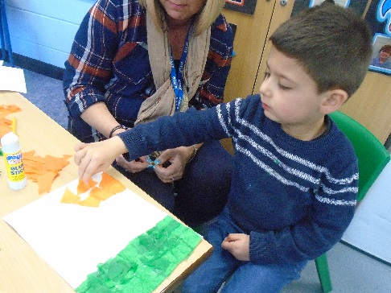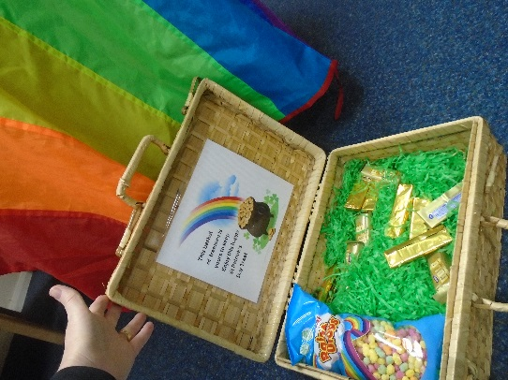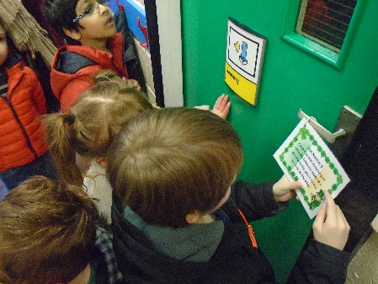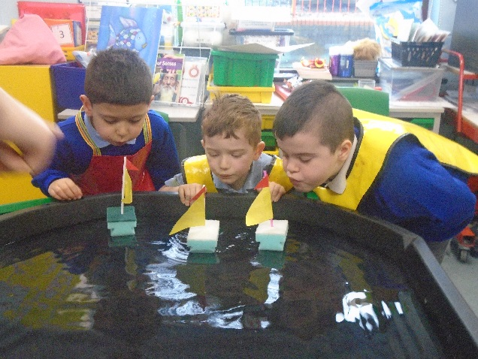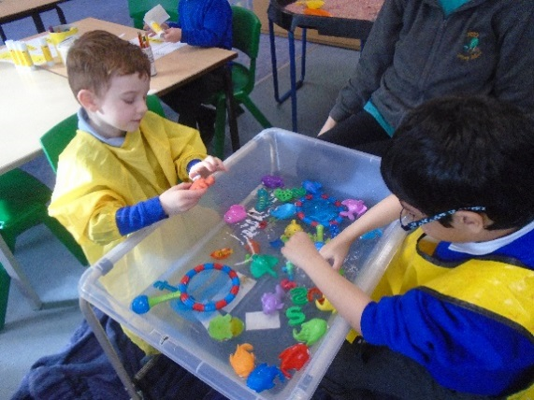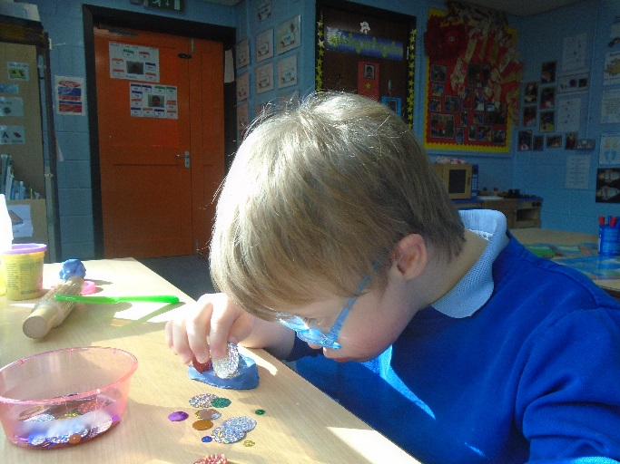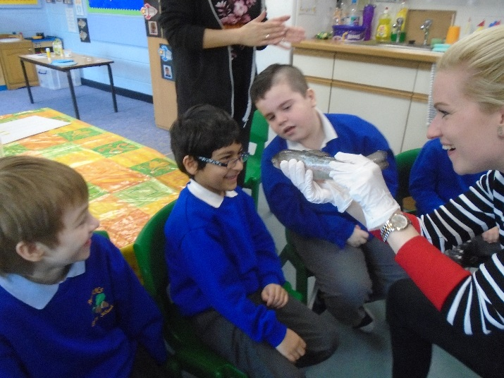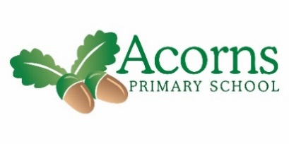

The children have started a new book called The Rainbow Fish. They have used adjectives to describe how beautiful it is! They have made beautiful glittery paintings and labelled parts of a fish after exploring a trout and sea bream using our senses. We decided the fish was shimmery. We liked opening its mouth!!! Deana didn’t like it quite as much! Mary kindly cooked the fish for us and some of us were super and tasted it. It was lovely! We made little boats and enjoyed racing them by blowing as hard as we could and finding out which boat finished in 1st, 2nd and 3rd place! We braved the windy weather and noticed our hair blowing, leaves rustling and trees waving in the wind. The rain made the mud nice and slushy so we enjoyed playing in the muddy puddles, making footprints and we noticed dog paw footprints. We have also enjoyed this week Celebrating St Patricks Day!! We learnt about Ireland and located it on a map, we watched some Irish dancing and had a turn ourselves – Brandon was impressive!! We listened to some Irish music, painted a clover and decorated biscuit in the colours of the Irish flag. In our PE we tried to dance an Irish jig and used the coloured scarves. On Thursday afternoon we enjoyed ‘Treasure Hunt’ around school – we looked for the Gold at the end of the rainbow!! A little leprechaun had left clues to follow, we were really good at the rhyming clues

**Next Week...** we will continue our wonderful work on the rainbow fish, have a visit to Stonyhurst College and celebrate the festival of Holi!!

Reminders- Please continue to read with your child and practice their flashcards ☺

Cedar Class Weekly News – 15/03/19