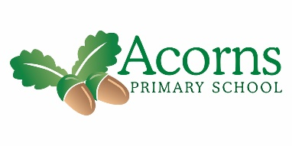

Pine Class News



**This Week...**

This week has been full of Christmas fun! The children have all enjoyed getting in the Christmas spirit!

Monday was Christmas dinner day, all the children and staff thoroughly enjoyed their Christmas dinner! Thank you to the kitchen staff, it was delicious!

On Tuesday morning we were all involved in Christmas games and won lots of prizes! In the afternoon we had a disco and had a special visit from **Father Christmas**. All the children looked brilliant in their party clothes!

Wednesday was our ‘Lights, Camel, Action!’ performances, the children were amazing and a credit to the school. Well done everyone and thank you to all the parents and carers who came to watch.

On Friday we celebrated the children’s achievements at our Christmas Award Winners Assembly. Well done to all the children who were nominated and won the awards! ☺

**We have all had a fantastic week!**

**And Finally…**

A **BIG** congratulations to Mason for winning the Achievement Award and also Kenzie for getting a special mention at Acorns Christmas Award Winners Assembly. We are all very proud ☺

**Reminders  
School re-opens on Monday 7th January 2019 at 8:55am.  
See you all then!**

**Next Week...**

All the staff in Pine Class would like to wish you all very Merry Christmas and a Happy New Year!

**See you all in 2019!**

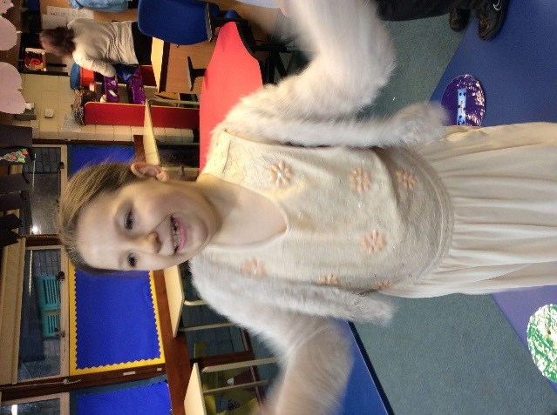

**Super!**

**Look what we’ve been up to this week…**

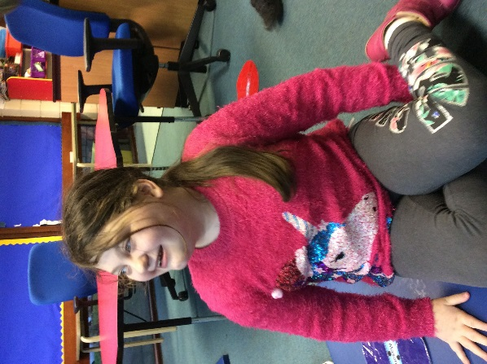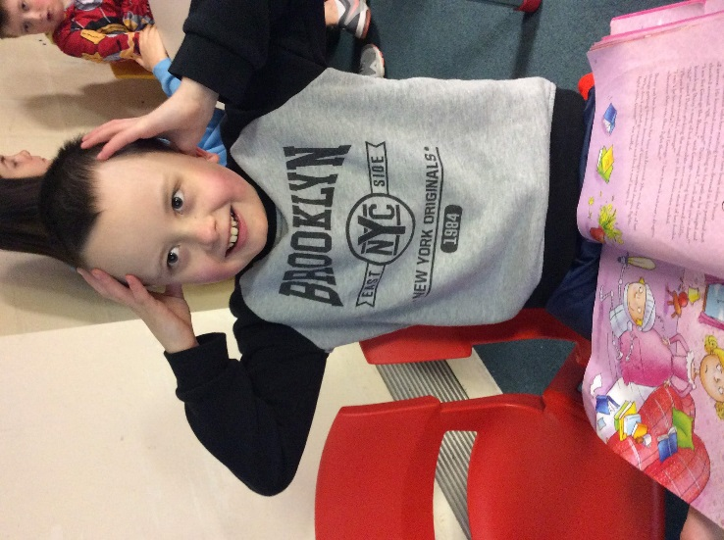

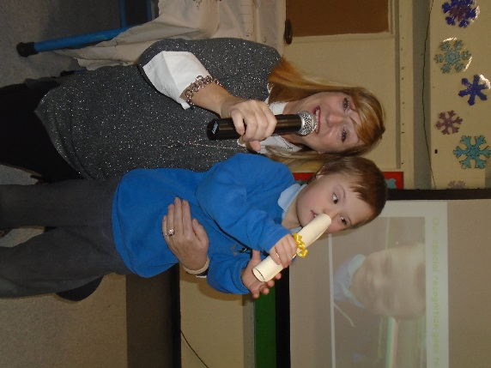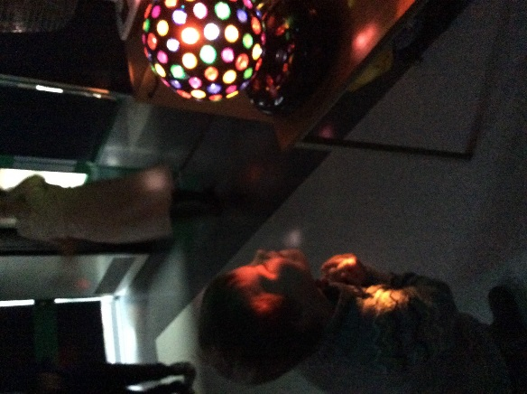

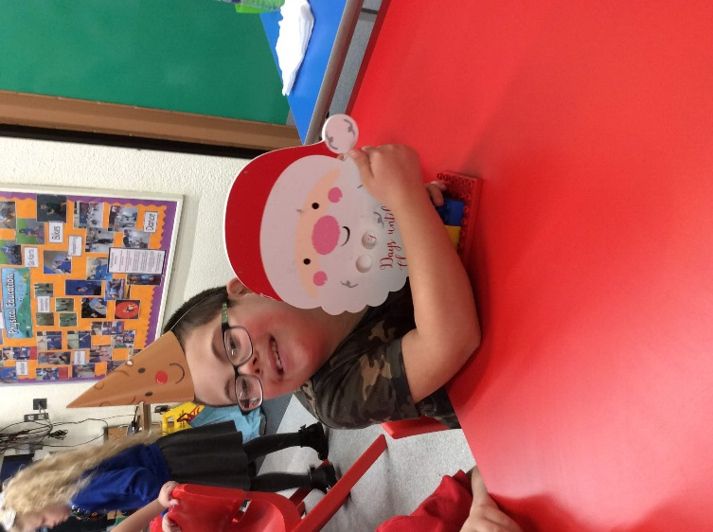

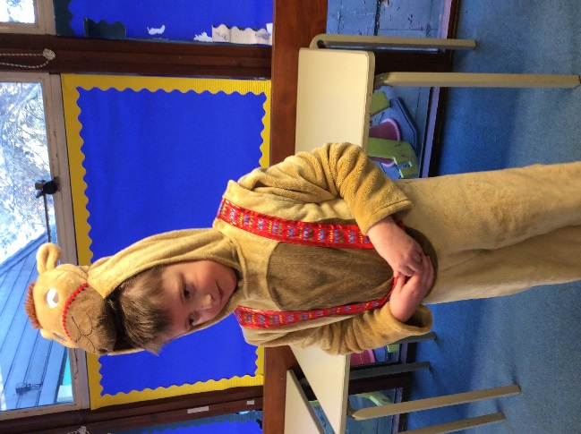

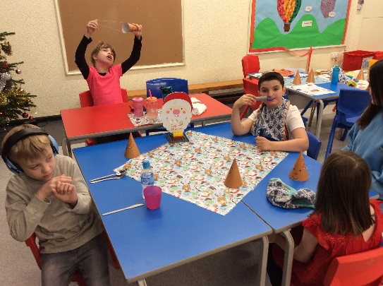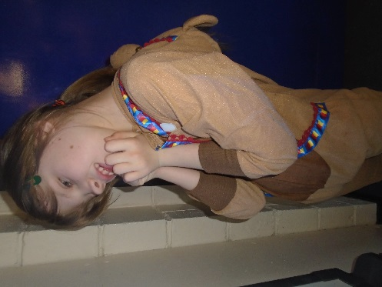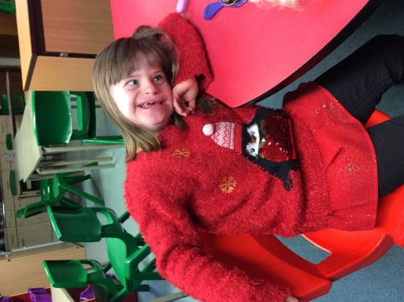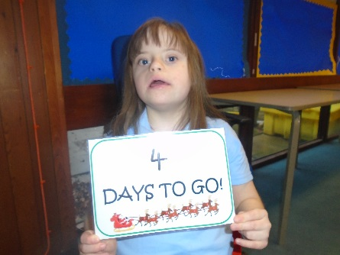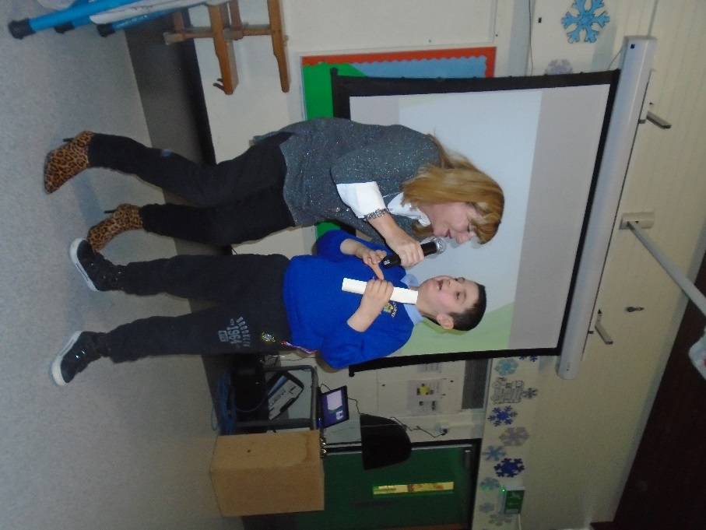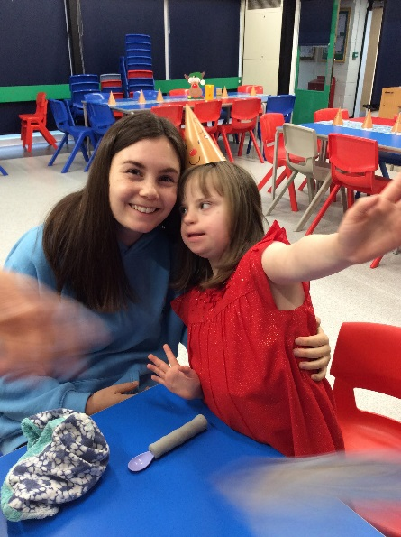

**Bethany all tired out from too much partying!**

**Another fun-filled week in Pine Class!**

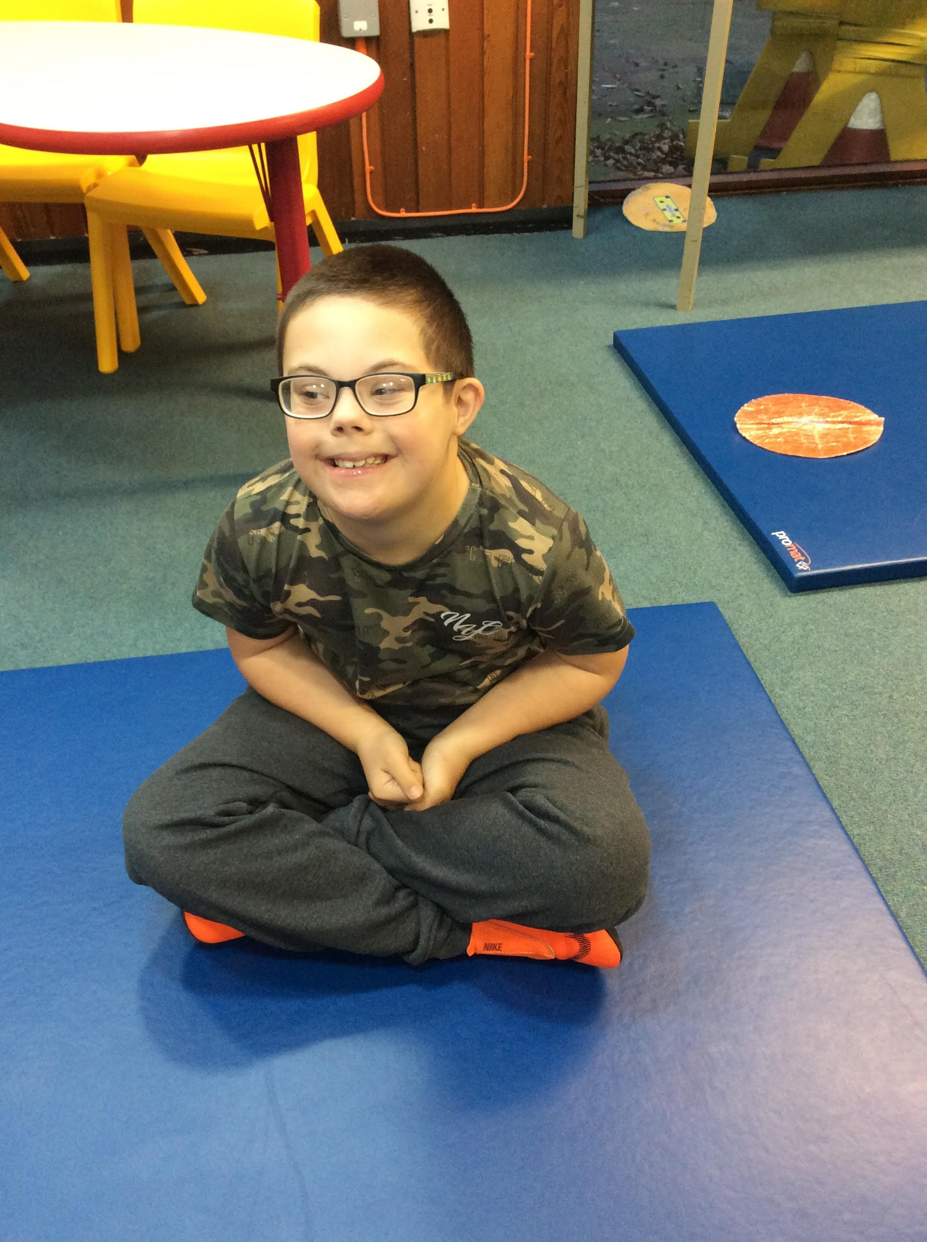

**PINE CLASS CHRISTMAS COUNTDOWN…**

**4 days to go!**