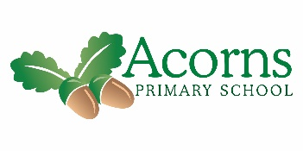

**W/B 29th April 2019**

Ash Class’s Weekly News

**And Finally…**

World Awareness Day was fantastic. WE were really lucky as we FaceTimed one of Mr Murphy’s Irish friends and asked her lots of questions.

**This Week...**

What a jammed pack 2nd week. In Science we started the week by discussing what a hazard was, what looked like and where you might find them in the house. IN art we started looking at impressionism and focused on Claude Monet. We looked at his ‘Water lily’s’ picture and used special water colour pencils to colour then paint our pictures. They look

amazing. On Wednesday we had

World Awareness Day. We looked at

Ireland and had a fantastic time

exploring the country, listening to music

and doing craft activities based on

Ireland. See the photo Video that I’ve

sent you.

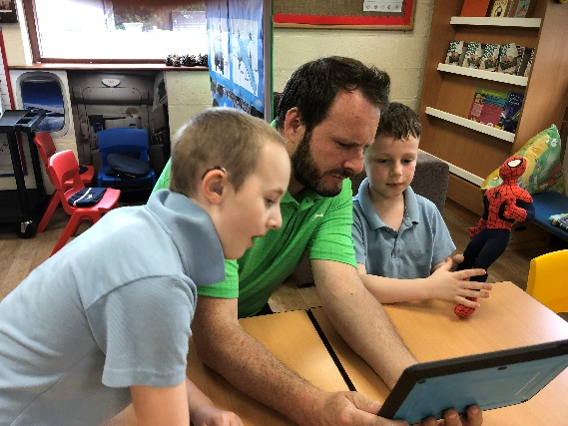 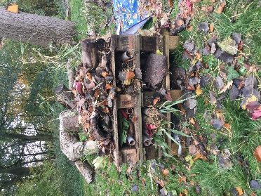

**Reminders**

We come back on 8th of May.

Polite request - class fund and snack fund are due, as it’s a 5 week term it will be £10 for this term.

If the children could come dressed up as Superhero on 10/5, Cash for Kids will be touring Preston and stopping at Acorns.

**Next Week...**

WE will a short week but we will be starting our new Computer unit on graphic packages.