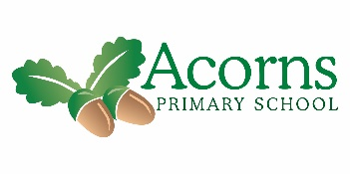

**This Week...**

This week we looked using different App to create funny pictures. We explored different types of puppets and looked into how to be safe around different medicines. In science we made cheese on toast and looked at a solid melting into a liquid then solidifying back again. In music we had a brilliant time singing ‘this is me’

from the Greatest Showman with

woodland class. And finally we

went to Shanaz’s Dad supermarket

to explore fruit from Handa’s

Surprise.

**W/B 14th January 2019**

Ash Class’s Weekly News

**And Finally…**

Your children were beautifully behaved whilst visiting the supermarket. They have fun smelling the different spices and tasting some exotic fruits.

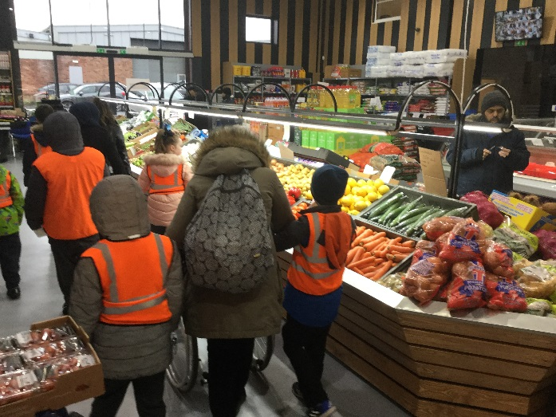 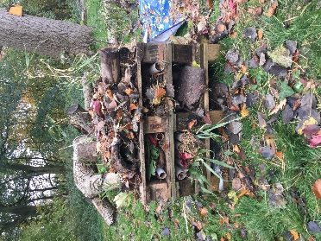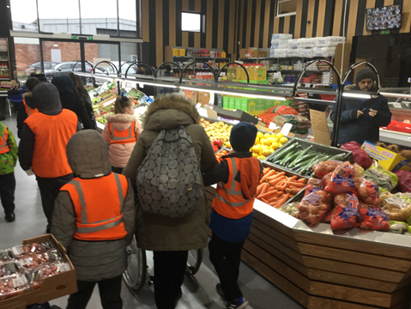

**Next Week...**

We are melting chocolate and letting it solidify.

**Reminders**

Polite request - class fund and snack fund are due, as it’s an 6 week term it will be £12 for this term.

Gemma do you have wellies?